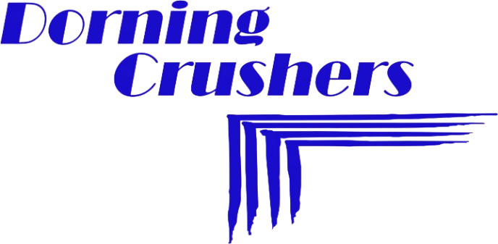
STONEWELL QUARRY (PTY) LTD
T/A DORNING CRUSHERS
P. O. BOX 402, KOKSTAD, 4700
STONEWELL FARM, KOKSTAD, 4700
TEL: 039-727 1976 ׀ FAX: 039-727 2381
VAT NO. 453 0198 128 REG NO. 2017/502047/07

15 July 2025

Mr. S.J. Strauss
c/o Ebenaeser Environmental Consultants cc
Occupational Hygiene
21 Ontdekkers Rd
Roodepoort
1725

Dear Mr. S.J. Strauss,
I.D. 5207185060080
Occupational Hygienist Cert. (SAIOH) No.0151
Mine Environmental Control (Advance) Cert. No. 375

APPOINTMENT OF OCCUPATIONAL HYGIENIST FOR MAHLUBI QUARRY IN TERMS OF SECTION 12.(1) READ WITH SECTION 7.(2) OF THE MINE HEALTH AND SAFETY ACT, 29 OF 1996

I, D Elliott, as 4.1 Appointee of the Mine Health and Safety Act, 29 of 1996 (MHSA), hereby appoint you, Stephanus Johannes Strauss, as the part time Occupational Hygienist in terms of section 12.(1) read together with section 7.(2) of the MHSA.

The purpose of this appointment is to assist me in the discharge of my duties in terms of the MHSA relating to the occupational hygiene measurement system within your area of responsibility.

Your area of responsibility is: Dorning Crushers. ( Kokstad & Portershoek)

This appointment will be valid from the date of my signature and will remain in force indefinitely, or until it is revoked in writing or until your services with the company are terminated for whatever reason.

For this position, the following duties and responsibilities are assigned to you and include, but are not limited to the following:

- In terms of section 12 of the MHSA you must take all reasonable measures to ensure compliance with the legal requirements and provisions pertaining to Occupational Hygiene.

- In terms of section 9 of the MHSA you are required to assist with the compilation of the relevant Mandatory Codes of Practice.

- In terms of section 11 of the MHSA, you must ensure that relevant hazards are identified and the related risks are assessed within your area of responsibility to which persons who are not employees may be exposed, and ensure that persons who are directly affected by the activities within your area of responsibility are not exposed to any hazard to their health and, determine measures necessary to eliminate, control or minimize the related risks.

- In Terms of Reg. 5.1.(1)(b)
Report to the employer on the adequacy in place to prevent detect and combat the start or spread of mine fires.

- i.t.o of Reg. 16.1 Report to the employer relating to Explosions, fires and flooding.

- You are required to ensure that the system of occupational hygiene measurements are:

(a) Appropriate, considering the hazards to which the employees are or may be exposed; and

(b) Be designed so that it provides information that the employer can use in determining measures to eliminate, control and minimise the health risks and hazards to which employees are or may be exposed.

- You are required to liaise with the appointed Occupational Medical Practitioner to ensure that proper record is kept of all occupational hygiene measurements in a manner that can be linked as far as practicable to each employee’s record of medical surveillance.

- It is your responsibility to report any shortcomings, in relation to the implementation of applicable legislation which you are unable to rectify, as hereinabove.

- You must also ensure that you are familiar with all group and internal health and safety standards, procedures, managerial instructions, codes of practice, permissions and exemptions as applicable during the period of your appointment. It will be your responsibility to ensure the implementation and adherence to these instructions and procedures in your area of responsibility.

- Furthermore, you must ensure that you are always familiar with the provisions of the mining legislation and all amendments thereto, as well as of other legislation which may impact on the activities at the mine within your area of responsibility.

From a statutory perspective you will report directly to me.

Kindly confirm your acceptance of this designation and understanding of the duties involved, by signing the attached copy of this letter and returning it to me. Please retain a copy of this letter of designation for your records.

15 July 2025
Signature of CEO Date

Acceptance

I acknowledge and accept the above appointment and declare that I am familiar with the duties, functions and responsibilities imposed on me by applicable legislation and this appointment, and undertake to ensure the implementation and adherence to these obligations.

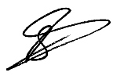
15 July 2025
Signature of Appointee Date
S.J. Strauss

